Standard 1 (Easy Read) template

Supporting your choices

This information is written in an easy to read way.
We use pictures to explain some ideas.

Some words are written in bold. We explain what these words mean.

You can ask for help to read this document.

A family member, friend or support person may be able to help you.

Let us know if you would like us to help you.

This Easy Read information is a shorter version of another document.

You can ask us (or Doing it Different) for a copy of the longer document.

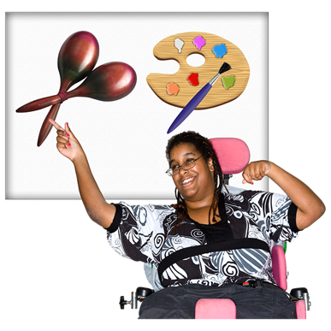

This information is about Choice and control.

Choice and control means you have the right to make choices about your own life.

You can choose what you want from our services.
You can make decisions about how things work for you.

Choice and control includes
- Choosing your own goals
- Picking which service providers you want
- Deciding how you will live each day and what you want from your life

We will
- Give you good information to help you make good decisions
- Help you make decisions, if you want help
- Ask your family and friends about decisions, if you want us to
- Following the law on decisions about your money, health and safety

If you make a decision and change your mind later that is ok.

We respect your right to make decisions and choices.

