Standard 1 (Easy Read) template

Privacy Policy

This information is written in an easy to read way.
We use pictures to explain some ideas.

Some words are written in bold. We explain what these words mean.

You can ask for help to read this document.

A family member, friend or support person may be able to help you.

Let us know if you would like us to help you.

This Easy Read information is a shorter version of another document.

You can ask us (or Doing it Different) for a copy of the longer document.

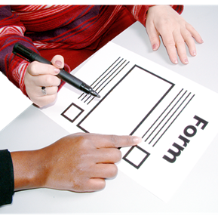

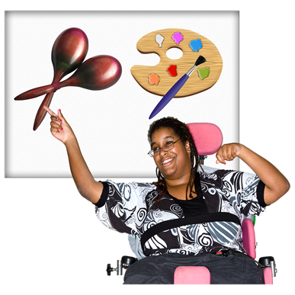

This information is about your Privacy.

We store information like
- Your name, address and phone number
- People who you are close to (mum, daughter…etc)
- Details about why and how we are helping you

This helps us to support you, and to check the quality of our services. We are responsible for keeping your information safe.

We use your information so we can work with you to design supports to suit you.

We only share your information if you say ‘Yes’, or if there is a situation that makes us.

We only share your information
- With a trusted person
- When we need to so you can be safe
- With your permission to provide required information to NDIS or other government organisations

When asked to share your information you can so ‘No’ or opt out of sharing it.

We keep your information safe so only those you say can see it.

You have several rights with your information:

- The right to see a copy of the information we hold about you
- The right to have inaccurate or incomplete information corrected by us
- The right to object to any information you think is inaccurate.

